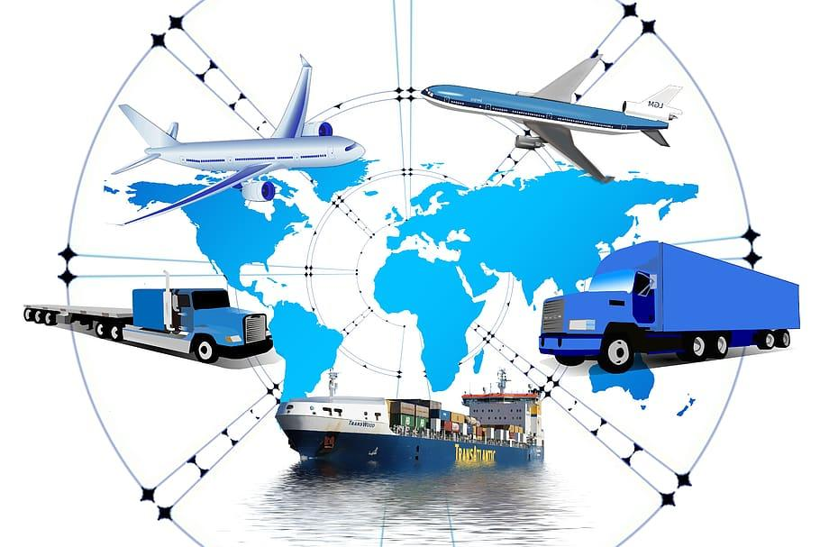

**Supply chain and logistics**

**industry:**

### **1. Demand Forecasting:-**

* **Problem: Inaccurate demand forecasting leads to overstocking or stockouts.**
* **Solution: Use time series forecasting models like ARIMA, Prophet, or machine learning models like XGBoost or LSTM to predict future demand based on historical sales, seasonal trends, promotions, and external data (e.g., weather, holidays).**

### **2. Inventory Optimization:-**

* **Problem: Maintaining too much or too little inventory increases costs or causes delays.**
* **Solution: Apply optimization algorithms and predictive analytics to determine ideal inventory levels at each location. Use ML models to forecast reorder points and lead times.**

### **3. Route Optimization for Delivery:-**

* **Problem: Inefficient routes increase delivery time and fuel costs.**
* **Solution: Use route optimization algorithms (like Dijkstra, A*, or Google OR-Tools) and real-time traffic data to minimize travel time and fuel usage. Combine this with clustering for batch delivery planning.**

### **4. Supplier Risk Analysis:-**

* **Problem: Unreliable suppliers disrupt production and delivery timelines.**
* **Solution: Use classification models (like Random Forest, SVM) to evaluate supplier performance and predict risks based on delivery delays, defect rates, or geopolitical data. Enable early warning systems.**

### **5. Warehouse Space Utilization:-**

* **Problem: Poor warehouse layout or space management leads to delays and inefficiencies.**
* **Solution: Use data clustering and simulation models to analyze item movement patterns and optimize warehouse layout. Computer vision can also monitor space utilization in real-time.**